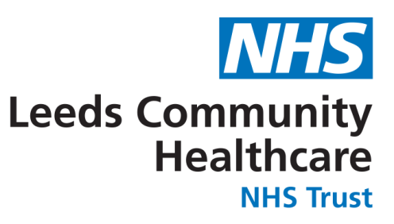

BCG REFERRAL PATHWAY
For your information

Dear Practice Nurse/Health Professional

Please find information how to refer a child requiring a BCG from a country with a prevalence of TB ≥ 40/100, 000 (please see link for list of countries)
http://www.hpa.org.uk/web/HPAweb&HPAwebStandard/HPAweb_C/1195733758290
(This link is also on the BCG referral form)

The referral forms can be located on the ‘Leeds Health Pathways’
- Search – BCG referral pathway
- Select – Referral info and forms
- Chose the appropriate form -

- Children under the age of 12 months will need to be referred to The Maternity LTHT baby BCG clinic (Form A).
- Children aged 12 months and over will need to be referred to the Leeds BCG clinic. (Form B).

For any enquires please do not hesitate to contact the TB Service on 0113 8434344

