IDDSI Thickened Fluid Guidelines – information for staff
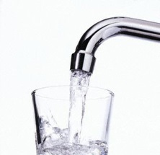 | - Flows like water  - Fast flow  - Can drink through any type of spout, cup or straw
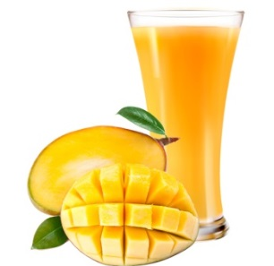 | - Thicker than water  - Flows through a straw, syringe or spout  - Similar to naturally thick fluids such as milkshake or mango juice
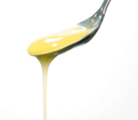 | - Flows quickly off a spoon  - Sippable  - Can be drunk through a straw with some effort  - Can be drunk from a cup  - Runs easily through a fork  - Leaves a thin coat on the back of a spoon  - Texture resembles syrup from tinned fruit or evaporated milk
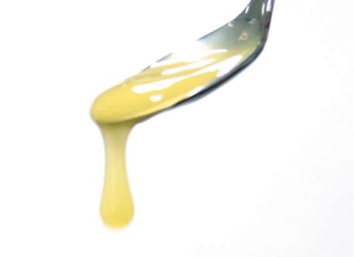 | - Can be drunk from a cup  - Cannot be drunk through a straw  - Drips through a fork in dollops  - Leaves a thick coat on the back of a spoon  - Texture resembles standard yoghurt
- Taken with a spoon
- Not possible to sip from a cup
- Cannot be drunk through a straw
- Sits on a fork
- Holds together well
- Texture resembles mousse or jam
- Falls off a spoon in a single spoonful when tilted
- Would hold its shape on a plate

