



October 2019

To: Leeds Care Home Managers

Dear Colleague,

2019/20 Seasonal Influenza Vaccination Campaign in Care Homes in Leeds (Nursing or Residential)
We are writing to you to seek your support for the 2019/20 Seasonal Influenza Vaccination Campaign in Care Homes settings in Leeds.
NHS England and NHS Improvement, Public Health England, Leeds City Council and Leeds Community Healthcare Trust are working together to support the campaign to improve influenza vaccination rates amongst your residents and health and/or social care staff who are in direct contact with vulnerable patients/clients in your care.
Influenza can be a serious, sometimes fatal, illness for older people many of whom have long term health conditions. The virus spreads rapidly due to close contact between residents and staff in care homes. Outbreaks often occur in care homes during winter, causing severe disruption to care homes, health and social care services. This includes reduced staffing due to sickness and delayed discharges from hospital. During October 2018 to March 2019 there were 52 recorded outbreaks of influenza like illness in care homes in Yorkshire and the Humber. Where outbreaks have occurred and been reported, investigations identified:
• Incomplete records of vaccination in residents
• Minimal records or evidence of vaccination in staff
Ensuring high uptake of the influenza vaccine in both residents and staff along with accurate recording remains a priority this winter.
Important information below describes the choice of vaccine available and access to the vaccination programme for both residents and staff:
Residents’ Vaccination
We would recommend that you discuss with your GP(s) the availability of the recommended free vaccine, as you may need to consider alternatives such as the community pharmacist who has opted in to deliver this programme, in order to ensure your clients receive the most appropriate vaccine in a timely manner.
Staff Vaccination
The national NHS Influenza Immunisation Programme 2019/20 offers free influenza vaccine for social care workers and health and care staff in the voluntary managed hospice sector, who offer direct care to vulnerable patient/clients who are at the increased risk from exposure to influenza.
Vulnerable means those patients/clients in a clinical risk group for influenza or who are aged 65 years and over. Arrangements have been put in place for eligible health and social care and hospice staff to receive a free influenza vaccination that can be accessed through GP practices and community pharmacy as part of the seasonal influenza programme. This staff vaccination scheme is intended to compliment and not replace the occupational health schemes already put in place by employers, to support influenza vaccination in 2019/20.
It is important to ensure that your staff have every opportunity to access an influenza vaccination to reduce the chances of them contracting influenza and passing it both between themselves and onwards to their families and patients/residents for whom they care.
Staff can receive their free influenza vaccines by taking appropriate confirmation of their eligibility to their registered practice or community pharmacy that is delivering this service. This could be an ID badge, a letter from their employers (containing care home logo/address and name of staff member) or a recent pay slip.

Key Documents
To support you with your Influenza Campaign this year Leeds City Council’s Health Protection Team are coordinating a mailshot that you will receive in early October. This mailshot will provide copies of key information posters and documents which can be used at your staff meetings and displayed in staff rooms to ensure you have everything in place to run a successful Campaign. The mailshot includes:

Across the north of England, NHS England and NHS Improvement and Public Health England will be repeating the 2018-19 award scheme to recognise the efforts made by care homes (residential and nursing), domiciliary providers and hospices who have achieved a high level of vaccine uptake. More information on the scheme and how to register will be provided in due course.
If you suspect there may be an outbreak of flu like or respiratory illness amongst residents or staff in your care home, please contact the Yorkshire and Humber Health Protection team immediately on 0113 386 0300. The quicker you report the quicker it can be dealt with and your site returned to normal business.
If you require further information to help support this local campaign please, please contact Sarah McMurray sarahmcmurray@nhs.net or Tracey Archer tracey.archer@nhs.net, Screening and Immunisation Coordinators on 0113 8252719.

Regards

Sally Eapen Simon
Screening and Immunisation Lead
NHS England & NHS Improvement North East and Yorkshire (Yorkshire and Humber)
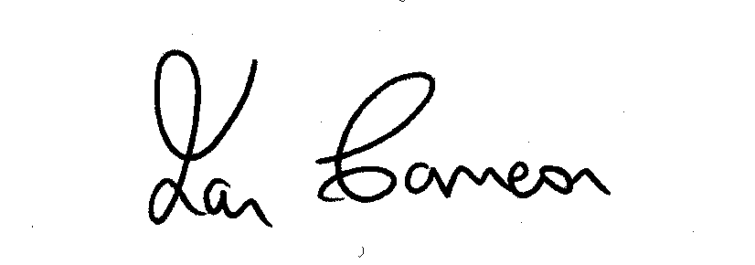

Dr. Ian Cameron
Executive Director of Public Health
Leeds City Council

